Introduction to Microsoft Excel is a two (2) to four hour course designed to familiarize students with terminology, screen components and the most commonly used functions offered by Microsoft Excel. Emphasis will be placed on file naming and file management conventions. Students will create and save a working budget which they may use for their own personal benefit.
Learning Goals:
- Identify the main parts of the Excel window.
- Identify the purpose of the commands on the menu bar.
- Work with the buttons on the toolbar.
- Explain the purpose of options available for printing a spreadsheet.
- Enter and format text and numbers into cells.
- Successfully move from one cell to another containing formulas and text.
- Copy, Cut and Paste text and formulas.
- Understand cell references.
- Perform basic mathematical operations in a spreadsheet.
- Copy, Cut and Paste text and formulas.
Definition:
Microsoft Excel is the spreadsheet component of the Microsoft Office Suite. It is used primarily to enter, edit, format, sort, perform mathematical computations, save, retrieve and print numeric data.
PAY SPECIAL ATTENTION TO TERMINOLOGY:
While different versions have different appearances, they all have most of the same features. If you know what to call it, you should be able to find it in other versions.

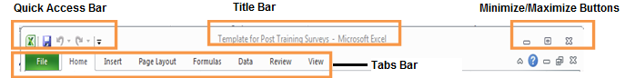
- Top of Excel Window
- Quick Access Bar
- Title Bar
- Minimize/Maximize Bar
- Tabs Bar
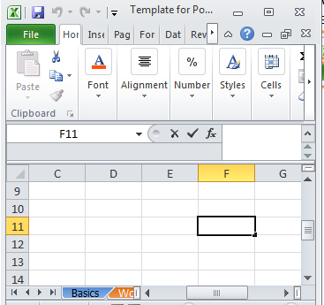
- Navigation Options
- I-Beam
- Horizontal Scroll Bar
- Vertical Scroll Bar

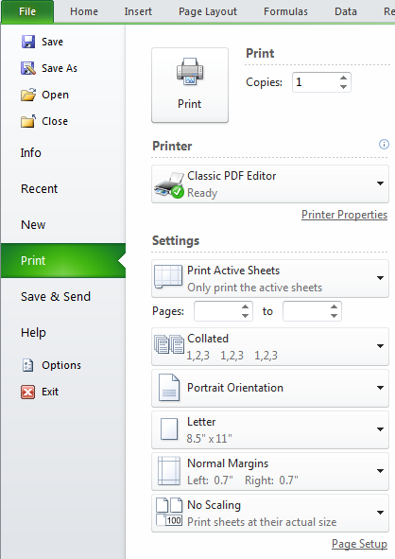
- File Tab Options
- Save
- Save As
- Print
  - Orientation
  - Scaling

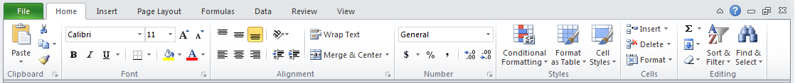
Ribbon Components
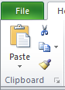
- Home Tab Groups:
- Clipboard
  - Cut/Copy/Paste

- Font
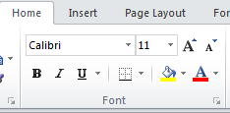
  - Face
  - Color
  - Size
  - Style (B, I, U)
  - Border
  - Shading

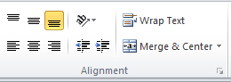
- Alignment
  - Horizontal
  - Vertical
  - Wrap Text
  - Merge Cells
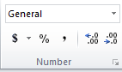
- Number

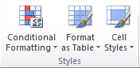
- Styles (Format as Table)

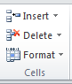
- Cells
  - Format

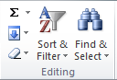
Editing
  - Autosum
  - Sort/Filter
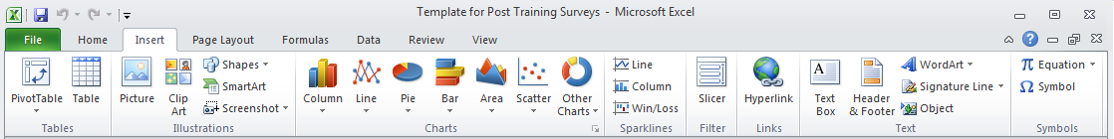
  - Find/Select
- Insert Tab Groups:
- Tables
- Illustrations (Pictures/Shapes)
- Charts
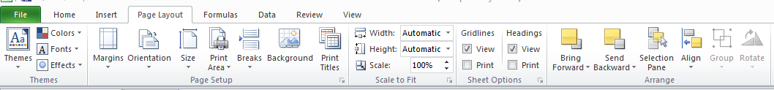
- Page Layout Tab Groups:
- Page Setup –Margins/Orientations

- Formula Tab Groups (more advanced options):

- Data Tab Groups: (more advanced options)
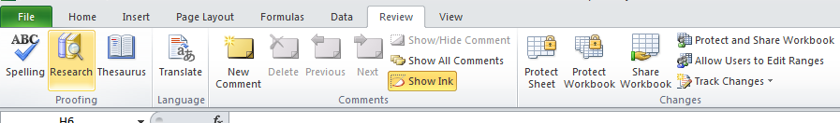

- Review Tab Groups:

- Spelling:
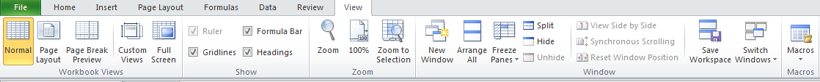
- View Tab Groups:

- Freeze Panes:
5.0.2 Creating a Monthly Budget appears below. You will follow these instructions along with your instructor. Use the completed budget after the instructions to help you.

Step 1: Enter and format text
Cell | Text to type in | Formatting
A1 | Monthly Income | Bold
A2 through A19 | Your income categories | N/A
C1 | Monthly Expenses | Bold
C2 through C19 | Your expense categories | N/A
E1 | Balance | Bold

Step 2: Enter and format numbers
Cell | Text to type in | Formatting
B2 through B19 | Your income amounts | Currency
D2 through D19 | Your expense amounts | Currency

Step 3: Enter and format formulas
Cell | Formula | Formatting
B20 | AutoSum | Currency
D20 | AutoSum | Currency
E20 | =B20-D20 | Currency and Bold  Red if negative and Green if positive

Step 4: Format borders
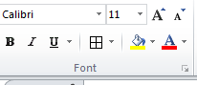
With your mouse, click on cell A1 and drag until your mouse pointer is on cell E20. Release your mouse. You should have the table highlighted in blue. Under the Home/Font group, find the borders icon. Use the drop down menu to choose All Borders.
Example Completed Budget
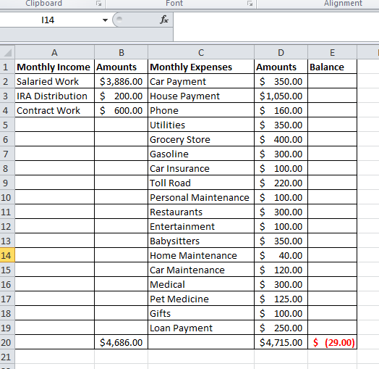

Microsoft Excel Terminology
Absolute Cell Reference: An absolute address in a formula refers to a specific cell location. Absolute references do change when you copy and paste or fill them down or over. Absolute references are created by adding a $ sign in front of each character in the cell address. For example, $B$4 will always refer to cell B4.
Active Cell: The active cell contains the insertion point and is identified by a dark border around the cell. Its address (location) is shown in the formula bar. Any action you perform is performed on the active cell.
Alignment: Horizontal alignment refers to the position of the contents of a cell in relation to its side borders.
Left Align | Centered | Right Align
Vertical alignment refers to the position of the contents of a cell in relation to its top and bottom borders.
Top Align | Centered | Bottom Aligned

Arithmetic Operators: The characters used to calculate numbers within a formula. Addition (+), Subtraction (-), Multiplication (*), Division (/)
AutoFill: AutoFill is the Excel feature that allows you to automatically copy cells and fill them down or across a series of cells.
Borders: Lines you may format around your cells or range of cells to enhance the readability and/or appearance of your spreadsheet.
Cell: A cell is the intersection of a row and a column. A cell can contain a label, a numeric value, or a formula.
Cell Address/Reference: The column letter and row number where the cell intersects. Example B4 is the intersection of column B and row 4.
Close: Use the Close command when you want to complete your work on a file and put it away without leaving Excel.
Columns: Columns are the vertical divisions of a worksheet identified by letters.
Default: A predetermined (by the manufacturer) setting for a particular command. Default settings can be changed.
Formula: A formula is a mathematical statement usually containing cell references and/or numbers and mathematical operators. A formula always starts with an equals sign (=).
Formula Bar: The formula bar is located under the toolbars at the top of the working screen. It contains the edit line for working with formulas and provides information regarding cell addresses.
Functions: A function is a preset formula. Functions consist of the function name and its arguments. The function name tells Excel what calculation you want it to perform.
Range: A range is a block of cells that can be selected, manipulated, named, and formatted as a group.
Relative Addresses: A relative address is a standard cell reference. Example: B4, U2. A relative cell references changes when copied and pasted to a new cell or is filled down a series of rows or across columns.
Rows: Rows are the horizontal divisions of a worksheet that are identified by numbers.
Sorting: Sort is a command which automatically arranges selected data alphabetically or numerically. You can sort in either ascending or descending order. It is important to highlight all of the data you want included in the sort.
Spreadsheet: The generic term for the type of program that allows for entering, analyzing, and calculating data. Common spreadsheet uses include analysis, charting, and budgeting.
Workbook: A workbook is a collection of worksheets saved as one file. The worksheets generally contain related material. The default number of worksheets in a workbook is three. These can be deleted or more worksheets can be added.
Worksheet: A worksheet is an electronic spreadsheet that lets you enter, analyze, and calculate data.
Wrap Text: Wrap Text is a cell formatting option that forces text to break into lines within a cell.

